AR606 AP Art History – Admission Essay – Required by:
Friday, February 26th, 2021

Part 1. Interest Statement

On a single sheet, (1.5 line space: up to 150 words - be sure to include your name on the page),
please write or type a brief statement explaining:

- What you wish to get out of attending the AP Art History Course?
- What interests, experiences, or strengths make you a good candidate for the course?

Part 2. Essay
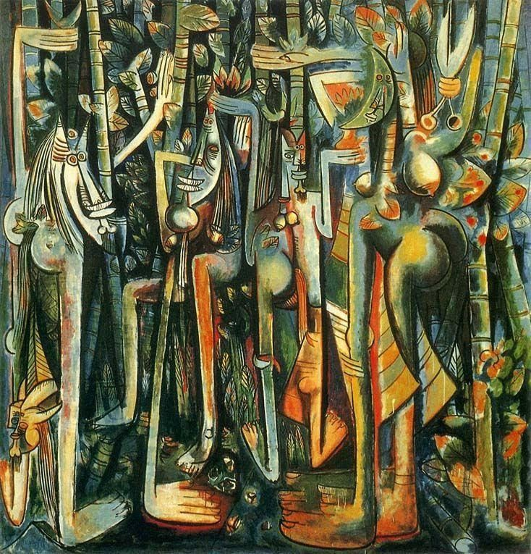

The Jungle Wilfredo Lam 1943 Gouache on Paper Mounted on Canvas.
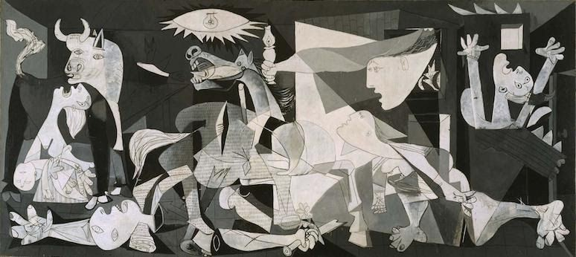

Pablo Picasso, Guernica, 1937, oil on canvas, 349 cm × 776 cm. (Museo Reina Sofia, Madrid)

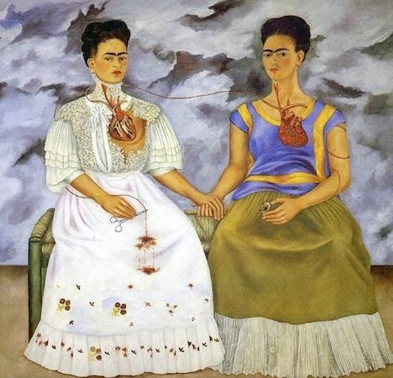

Frida Kahlo, The Two Fridas (Las dos Fridas), 1939, oil on canvas, 67-11/16 x 67-11/16 inches (Museo de Arte Moderno, Mexico City)

Consider one of the three paintings shown, and on a named, separate single sheet of paper, write a brief essay, (approximately 250 words), that incorporate some of the following points:

Describe your response to that work by discussing some of the following:

- Why do you think the artist chose the subject?
- Why did the artist use color or no color in his particular way?
- The artist’s technique.
- The overall mood or message the artist conveys to you.

Do remember that Art is very subjective, and as such, please feel completely free to express your honest opinions!

