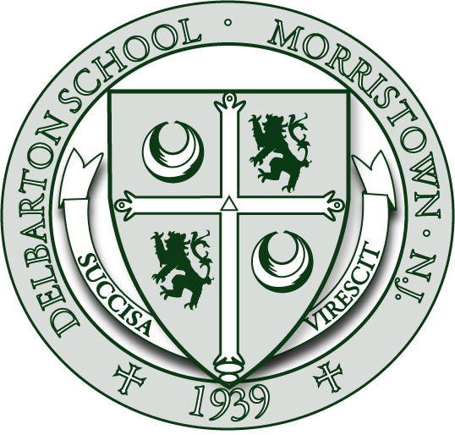ADMISSIONS: STEP BY STEP

Selecting the right school is a significant and exciting decision. The Delbarton Admissions Office stands ready to assist you in whatever way we can. Our primary interest is helping to find the correct match between student and school.
PERSONAL INTERVIEW

An essential part of the admission process is the personal interview of the student and his parents. Interviews are scheduled for Saturday mornings 9:00 a.m. to 12 p.m. from September through mid-December. Applicants may choose the time and date available in the schedule module. A member of the Delbarton Admissions Committee will conduct the approximately 40-minute interview speaking first with the applicant and then with his parents. We view the interview as an opportunity for a friendly and open conversation to learn more about one another.

Finally, during your interview morning, a recommended campus tour for each family is provided by a Student Ambassador.

ENTRANCE EXAMINATION

Delbarton schedules its own entrance examinations two times a year in November and December. Applicants register for an examination by selecting a date in the Online Application Part I. The exam covers three areas: aptitude, subject knowledge, and writing fluency. Delbarton School, upon specific written request, will honor necessary testing accommodations for students if they provide formal documentation of eligibility through a Professional Educational Evaluation.

On the day of the entrance examination, students should check in by 8:30 in Trinity Hall. While students are taking the entrance examination from 9:00-12:30 a.m., parents are invited to remain for an information program about Delbarton which lasts from 9:00 to 10:30 a.m. in our Fine Arts Center auditorium. This speakers program will allow prospective families to hear directly from members of our school community including students, parents, and alumni.

STUDENT FOR A DAY

Delbarton is suspending its “Student For A Day” program for the 2021-22 admission season.

EVALUATION AND SELECTION

The Admissions Committee will look at three broad spheres of a candidate’s profile: his overall character and personality, his academic performance and potential, and his areas and levels of co-curricular contribution. The Committee will evaluate the applicant’s character and personality as they are revealed in the interview and recommendations. In assessing the academic qualifications of the candidate, both his academic record and intellectual promise are assessed in light of his school grades and standardized testing results. Finally, the co-curricular interests and successes of the applicant are examined. This information is sought through the formal application and personal interview.

We encourage you to contact our office to ensure that all parts of the application have been received. Deadline to begin the application for admission is November 30. The Admissions Committee meets in mid-January to make its decisions for 7th and 9th grade candidates. Decisions for 8th, 10th and 11th grade candidates are made between February and mid-June.

In addition to decisions on students who are accepted and declined, a waitpool of qualified 7th and 9th applicants is formed by the Admissions Committee in late January. This list is maintained until mid-June. Places that open up for the 7th and 9th grades will be filled with applicants from the waitpool. Once all spaces have been filled, waitpooled candidates will be sent a letter in mid-June informing them that the class is full.

FINANCIAL AID PROGRAM
We know that the financial commitment to an independent school can be beyond the reach of families with qualified students. Consequently, Delbarton has developed over the years the resources to aid families to bridge the gap between their means and the School’s expenses. Delbarton seeks a broad diversity in its student body and is committed to making its educational opportunities available to exceptional young men regardless of race, color, creed, or financial status.
Delbarton School is proud of its financial aid program and encourages candidates seeking financial assistance to apply. We believe that a generous financial aid program is vital to the health and success our school community. All awards take the form of outright grants and are issued according to the family’s demonstrated financial need as determined by TADS, an independent financial aid service. The link to TADS can be found on our website under Admissions. Financial aid considerations are made separately from admission decisions and are kept strictly confidential. The School will notify financial aid applicants of award decisions with admission decisions in January. Delbarton will waive its application fee for families who are applying for financial aid. Finally, if you are interested in a rough estimate of your likely financial need, please contact our Director of Financial Aid, Dr. David Donovan at ddonovan@delbarton.org or 973-538-3231 x 3022.
We do not want cost to deter families from considering Delbarton School as a viable educational option. Please feel free to contact our admissions office if you have any questions regarding our school or its admission and financial aid processes.

